**Fast Neutron Multiplicity Counter Simulation**

## Why we chose GEANT4

The simulation of the FNMC setup is done using GEANT4 software. We used GEANT4 for its simulation capabilities of the response of detectors to incident neutrons and gammas originated from fission. GEANT4 physics processes are well maintained and validated, especially for simple interaction of gamma particles and neutrons with matter, as in our case. The implemented physics list is based on cross section libraries from different nuclear databases, an example is attached:

Figure 1 -GEANT4 cross section validation, taken from Žugec, Petar (2016). Integral measurement of the 12C(n,p)12B reaction up to 10 GeV. European Physical Journal A : Hadrons and Nuclei:

We are interested to measure fission events as correlated events in our setup. GEANT4 is using a Lawrence Livermore National Laboratory fission model to simulate the energy and multiplicity of prompt neutrons and gammas. *(J. M. Verbeke, C. Hagmann, and D. Wright, "Simulation of Neutron and Gamma Ray Emission from Fission," Lawrence Livermore National Laboratory, UCRL-AR-228518, May 2010.)* This model does not include correlations between gammas and neutron, due to lack of relevant data and models for this kind of correlation.

We confirmed the energy and multiplicity generation of the implemented model using simulation of decaying 252Cf, based on QGSP_BERT_HP physics list and RadioactivePhysics module and get the following figures:

Figure 2- Distribution on prompt neutron energy for different multiplicity.

Comparing it to validation that was done in GEANT4 and MCNPX-PoliMi:

Figure 3- Distribution on prompt neutron energy for different multiplicity , base on: S. F. Naeem, S. D. Clarke and S. A. Pozzi, "Comparison of GEANT4 and MCNPX-PoliMi fission models," 2012 IEEE Nuclear Science Symposium and Medical Imaging Conference Record (NSS/MIC), 2012, pp. 1003-1005, doi: 10.1109/NSSMIC.2012.6551258.

The gammas multiplicity agrees as well:

Figure 4- Calculated GEANT4 gamma multiplicity

Compared to the same paper:

We see a good agreement for generation of neutron and gamma energy distribution and multiplicity.

## Simulation Procedure

Each fission event was simulated by placing a stationary 252Cf nucleus. Then, using the GEANT4 default decay physics the nucleus undergoes fission with a known branching ratio.

We simulate the detectors using four slabs made of plastic scintillator, and the material is given by GEANT4 default material library. To simulate the measurements, we assumed that the detectors are only sensitive to gammas and neutrons from the fission, and neglected possible alpha particles, beta particles, and fission fragments in the detectors.

To simulate the pulse formation in the detector, we saved every step of gamma and neutron and the detector with positive energy deposition. For the neutron, we applied a stricter cut and required a production of secondary proton as well. This requirement is done to simulate the scintillation of heavy charge particles. In more details, in this detector neutron most of the time interacts with the nuclei of the matter, hydrogen, carbon and oxygen. It is assumed the light yield of carbon and oxygen can be neglected compared to the protons, so only events with proton energy deposition are saved for neutron.

**We need to add why we don’t add optical photons here**

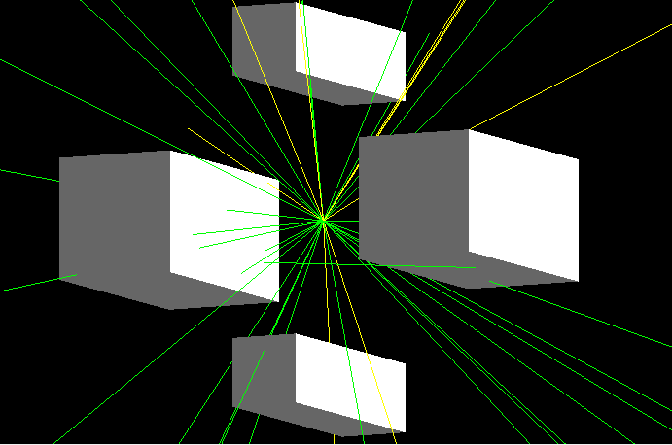

Figure 5- Three fission events simulated in GEANT4. The scintillators are the white tubes, the neutrons are marked by yellow lines, the gamma particles are marked by green lines

Using the saved fission events form GEANT4, we created simulated pulses at the detectors. We used a time window of 20ns to sum over events that occurred in the same detector in the same window. In addition, we used energy threshold on the gamma and neutron events to filter events that didn’t deposit enough energy to reach the trigger criteria.

## Results

In the following graphs one can see the results from the simulation. For sanity check, we extracted the time-of-flight distributions of the gammas and the neutrons. One can notice two distinct peaks in the gammas distribution that corresponds to the two locations of the detectors, because the thicker detector is closer to the source. We confirm that using the peaks times $0.14 ns$ and $0.18 ns$.Multipling by the speed of light we get $42 mm$ and $54 mm$, and those are the distances between the detectors faces and the source. The decay following the peak is coming from the decay of radiation flux incident on material.

Figure 6- Distribution of the time of flight of the detected gamma particles.

The neutron TOF distributions show a wider spread due to the spread in the energy, which leads to spread in the velocity. Because of the high threshold for neutron detection, we see relatively small time of flights, and we don’t see 1 MeV neutrons. A 2.4 MeV neutron will have a TOF of around $2.3 ns$ considering the dimensions of the setup, and this agrees with the histogram from the simulation.

Figure 7- Distribution of the time of flight of the detected neutrons.

To further confirm the neutron data, we can examine the following graph and see that there is negative correlation between time and energy of neutrons, as expected, because slower neutrons have lower energies. There is no exact relation in the graph because the neutron does not deposit all it energy in the interaction.

Figure - Relation between TOF of neutron and its detected energy.

A post- analysis code written in python, outside of the GEANT4 simulation, was used to simulate the time difference between fission events. We introduced a global time, and the time between decay events was simulated using exponential distribution. The rate of this distribution was the rate of the decays in the sample, which is calculated using the activity of the source.

For the following graph, I took a mass of $1 ng$, for 12.4 seconds. The following Rossi-alpha shows the distribution of the time difference between each pair of detected events.

